# INTRODUCTION

* 1. 1.1.Overview

Generally , house price prediction can help the developer to determine the selling price of a house and can help the customer to arrange the right time to purchase a house.

To help people find their own homes And the fact that did not change is that Mukesh Ambani house , Antilia , is the most expensive property in India.

* 1. 1.2.Purpose

People are enabled to get a required housings, and are supposed to get with a affordable prices.

It helps people to get more connected with housing knowledge.

1. **Problem Definition & Design Thinking**
   1. 2.1.Empathy Map

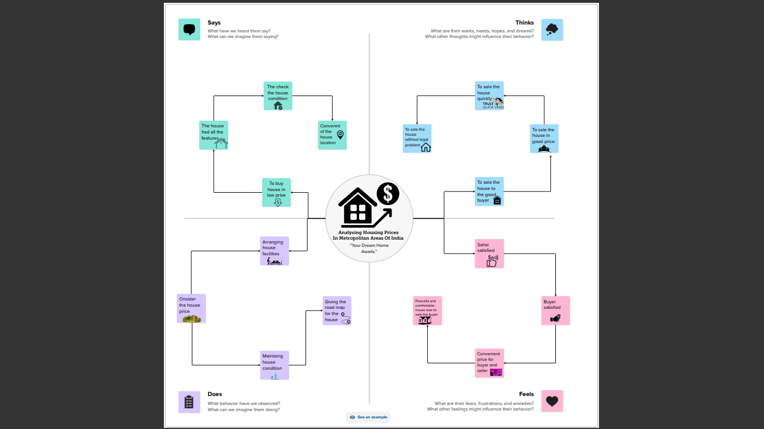

* 1. 2.2.Ideation & Brainstorming Map

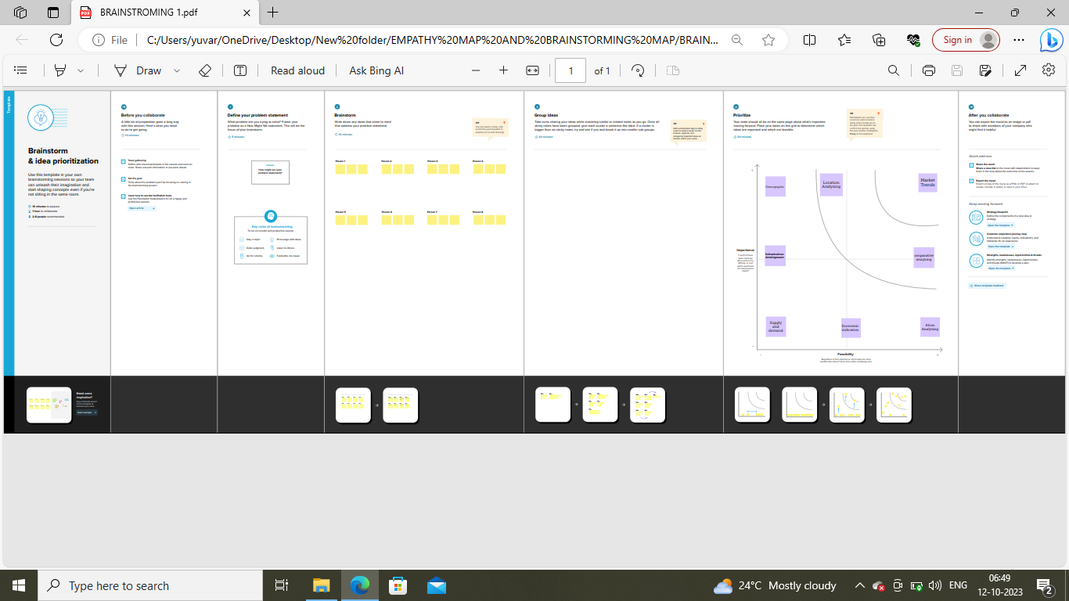

# RESULT

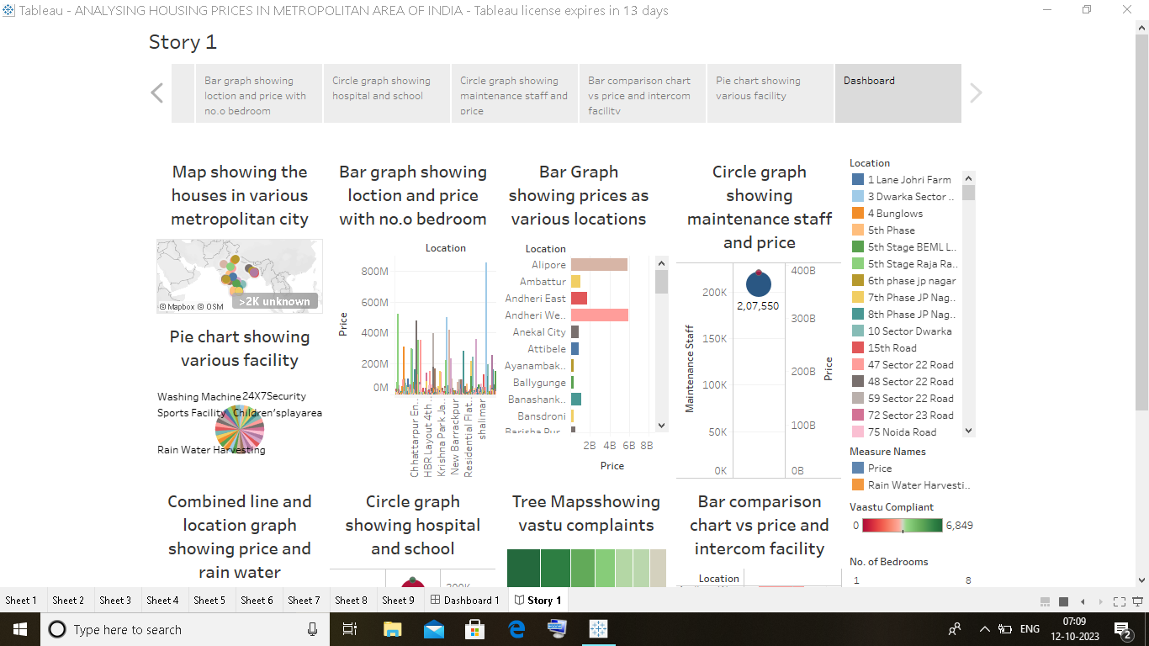

# ADVANTAGES & DISADVANTAGES

4.1.ADVANTAGES

* More job opportunities
* Greater variety of entertainment and dinning options
* More public transportation options.
* The advantages include access to better schools , more job opportunities.
* More mobility
* Limited financial obligation.
* Renovating choices.
* Pride of ownership.

4.2.DISADVANTAGE

* Lifestyle limitations.
* No equity growth or store of value
* Crimes such as murder , kidnapping, crimes against women , senior citizens and cyber-crimes are the biggest problems .
* It’s expensive. The cost of living is high in most big cities , which can make ends meet if you don’t have a high-paying jobs.
* Because of larger populations , cities can have high level of pollution , including noise pollution. This could be damaging to your health in the long term.
* If you have pets you may find it harder to find a place to live that allows them. It may also be harder to find a place to walk a dog or enjoy outdoor space with them.
* It doesn’t predict future prices of the houses mentioned by the customer.
* Expensive property leads to an increase in rents because rented housing is a substitute for owner occupation . This reduces geographical mobility.

# APPLICATIONS

* It offers limitless social potential for making friends and networking.
* It foster personal bonds.
* Hospitals are outfitted with cutting- edge technology, a group of elite medical professionals or first rate services.
* High speed internet access in the form of Fiber and 5G.Lower risk to entrepreneurship.

# CONCLUSION

* This paper aims to examine the dynamics of house prices in metropolitan cities in an emerging economy.
* The purpose of this study is to characterize the house price dynamics and the spatial heterogeneity in the dynamics

# FUTURE SCOPE

Prediction house prices are expected to help people who plan to buy a house so they can know the price range in the future , then they can plan their finance well. In addition,house price predictions are also beneficial for property investors to know the trend of housing prices in a certain location.